A000-AUS-W-Kimberley-Boab Nut-Carvings-early 1900’s

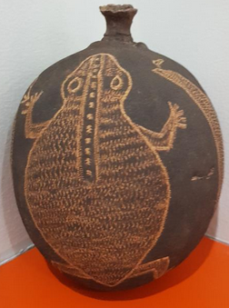

**Case no.: Oceania**

**Accession Number:**

**Formal Label:** AUS-N-Kimberley-Boab Nut-Carvings of Emu-early 1900’s

**Display Description:**

The only place in the world to find the unusual boab tree is the Kimberley in Western Australia. From Darwin or Katherine the first boab tree is in the approach to Victoria River and Gregory National Park. Across the Kimberley, through “Kununurra,” which in the Miriwoong language is really spelled "Goonoonoorrang", which means large river. In fact, all the boab trees are very dependent on nearly rivers since their spongy tissue in their trunks that act as massive barrels from which sprout delicate branches and small leaves only on top. Since these branches main job is to issue seeds or nuts to propagate their species and not to acquire rainfall from their small leaves, the main job of acquiring water and therefore life is left to the roots. Yet this strategy has been very successful, since some boab trees have been determined to be 6000 years old, which makes them the oldest living beings in the world. Aboriginal Australians use these giants as shelter, food and medicine, and that is why the engravings on the surface of these nuts are so important because they encode messages from the past on important Australian resources.

**LC Classification:**

**Date or Time Horizon:**

**Geographical Area:**

**Map:**

**GPS coordinates:**

**Cultural Affiliation:**

**Media:**

**Dimensions:**

**Weight:**

**Condition:**

**Provenance:**

**Discussion:**

Boab trees are deciduous, they drop all their leaves during the dry season.  
When the wet season approaches the trees sprout new leaves when the first rains arrive. Big, white, pinkish hue flowers bud in October. The nut emerges around January and is covered with fine light olive “hair,” under which is the brown boab nut, which is a woody oval capsule that contains several kidney-shaped seeds inside a white pith.

**References:**